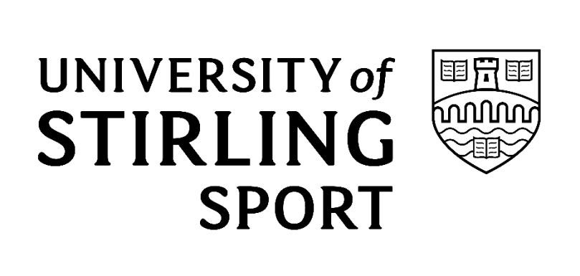

Introduction

The University of Stirling Football Club (UOS) is a member of the Scottish Women’s Premier League and is recognised as being among Britain’s top Universities for football and performance sport. In addition to fulfilling all SWPL league and cup fixtures, we also participate in the British and Scottish University football competitions.
The UOS will not tolerate unacceptable conduct from the Clubs employees, committee members, players or supporters at the University or at any other away football stadia.

Unacceptable Conduct Policy

UOS aims to create and maintain an environment where spectators can enjoy the game of football, safe in the knowledge that they are free from all forms of harassment, abuse, unacceptable or disorderly conduct.
This policy applies for any football matches or events within the University grounds or at any away ground fixtures.

Definition



Unacceptable conduct is conduct which is violent or disorderly. Conduct is violent where there is: Actual, attempted or threatened physical violence against a person or persons Intentional damage to property.

Disorderly conduct involves any activity which stirs up or sustains, or is likely, or is designed to stir up or sustain hatred or ill will against or towards individuals or groups of people because of:

Gender
Age
Colour, race, nationality (including citizenship) or ethnic or national origin
Membership or presumed membership, of a religious group or of a social or cultural group with perceived religious affiliation

Sexual orientation
Transgender identity
Disability
Using threatening, abusive or insulting words or conduct both verbal and non-verbal Displaying writing or any other item which is threatening, abusive or insulting.

Racism

UOS condemns racism in any form, either on or off the pitch. UOS aims to create and maintain a working and spectating environment free from racial harassment and abuse. Everyone connected
with UOS has a responsibility to prevent racial harassment or abuse.
A racist incident is defined by UOS as any incident that is perceived to be racist by the victim, or any other person. Racial harassment is defined by UOS to be any verbal, physical, written or visible abuse that is based on a person’s race, ethnic background, colour, nationality, language or cultural background – and is considered to be unwanted, unacceptable and offensive to the person.
Proven racial harassment or abuse will lead to action being taken against spectators and will be reported to the police and may result in a life ban from UOS. UOS will give their full support to the police in any criminal actions.
All employees, committee members, players and servants of the Club have a responsibility to make it clear that such behaviour by anyone connected with UOS is unacceptable.
Supporters should also note that racist taunts and abusive or threatening behaviour will not be tolerated by UOS and will be encouraged to condemn and report such behaviour.
Any supporters (home or visiting) behaving in this way will face eviction from the stadium and their actions will be reported to the police. Season ticket holders who conduct themselves in this manner face having their season ticket revoked and all spectators face the prospect of a life ban from the University grounds and Forthbank Stadium
UOS fully supports and will promote the Show Racism the Red Card Campaign, details of which can be found at www.srtrc.org.

Sectarianism - Kick Out Bigotry the Pledge

Scottish football fans have earned a worldwide reputation for their enthusiastic and good-natured support of the national team. While most fans follow club football in a responsible way, there are occasions where individuals are intent on causing trouble, using football as an excuse for bigoted and unacceptable behaviour.
By working together to remove bigotry from our football grounds we can demonstrate that Scottish football fans and in particular UOS supporters:
Respect people of all backgrounds and celebrate the multicultural society that Scotland has become in the 21st Century
Want their football clubs, and the support for their clubs, to reflect the diversity of modern
Scottish society and
Are as passionate about their football clubs as they are about their national team.

Consequences

ANY PERSON ENGAGING IN UNACCEPTABLE CONDUCT MAY BE SUBJECT TO ANY, OR A COMBINATION OF THE FOLLOWING:

Removal from the University grounds or away stadium
Suspension from attending home matches involving UOS
Indefinite ban from attending home matches involving UOS
Suspension or ban from holding UOS membership
Suspension or ban from the UOS Committee Suspension or ban as a Player or Coach from the UOS Report to the police and possible criminal proceedings.

Responsibility

Everyone associated with the Club has a responsibility to prevent and discourage any form of abuse and as such are responsible not only for their own actions but also those of others. We would therefore encourage everyone to bring to the Club’s attention, any incident or behaviour, of individuals or groups of individuals, deemed to be in breach of this policy.
Whilst it is appreciated that behaviour such as that listed above involves the minority of individuals in our society, UOS wishes to ensure that we continue to maintain the highest standards both on and off the field of play and that the name 'University of Stirling Football Club' is associated with good and sporting behaviour at all times.

Reviewed: December 2025
Review Date: December 2026

